A mini report

- Paritosh Sinha

**Title: Decoding the Fizz: A Reddit Listening Campaign for Coca-Cola**

As a brand's strategy depends on an understanding of public perception. This report shares findings from a social listening campaign that took place within the coca cola subreddit on Reddit.

**Methodology**

# Data Extraction -

We used Reddit's API to extract data from the Coca-Cola subreddit with the help of PRAW (Python Reddit API Wrapper). Over a predetermined time, we gathered a variety of data points, such as post

titles, body texts, metadata, and user engagement metrics (like upvotes, downvotes, and the number of comments). Our social listening campaign is built around this extensive dataset, which provides a solid basis for the analysis that follows.

# Analytical Tools -

We used a number of analytical methods and tools to turn the massive amounts of raw data into useful insights:

* Natural Language Processing (NLP):
  + Using natural language processing (NLP), we sifted through post titles and body content to find popular keywords and extract hashtags—which serve as indicators of popular subjects and conversations.
* Sentiment Analysis :
  + We measured the emotional tone of the subreddit's content using sentiment analysis libraries, classifying it into positive, neutral, and negative sentiments.
* Influencer Identification:
  + We identified important community influencers whose activity greatly shapes the conversation by examining engagement metrics and network patterns.
* Community Detection:
  + Using network graph analysis, we were able to distinguish between different communities inside the subreddit and determine how discussions and interactions were organised.
* Readability Assessment:
  + To determine whether the content is accessible to a wider audience, the readability of the post was assessed using recognised metrics such as the Flesch Reading Ease and Flesch-Kincaid Grade Level.

## Data Analysis and Key Insights

* **Spotting Trends: Keywords and Hashtags**

Our extensive exploration of the Coca-Cola subreddit revealed the most frequently discussed words and phrases. Identifying the most talked-about topics in the community, we used

Natural Language Processing, an intelligent method of interpreting and deciphering language in data. These hashtags and keywords serve as road signs, letting us know what the members of the subreddit are genuinely enthusiastic about—from vintage Coke recollections to the newest tastes to hit the market.

## Identifying the Influencers

There are certain users in the subreddit who are considered influencers and are the people to talk to about Coke. We identified these people by looking at who initiates the most conversations and receives the highest thumbs-ups. They are significant because they

influence how other people perceive and discuss Coca-Cola.

## Visualizing the Conversation

To add clarity and interest to our findings, we included: A word cloud is an entertaining visual aid for determining which words appear most frequently. More references are made to a word the larger it is. A graph that indicates who actually drives the discussions in the

subreddit by ranking the most active talkers.

## What the Information Indicates

People discuss what makes Coca-Cola special to them and share their love of the drink in this lively subreddit. In addition to talking about the beverage, they are exchanging anecdotes and anticipating new Coke products. The influential members of the group have a significant influence on how these conversations are steered.

# What We discovered

Entering the Coca-Cola subreddit has been like walking into a lively celebration of soda lovers. It's a place full of goodwill and lively discussion about the brand's exciting future prospects as well as its

rich history. A few major themes emerged from the community's conversation. Most talks consist of lighthearted banter about fond memories of Coca-Cola or discussions about which flavours are the best. When significant news breaks, such as the release of a new flavour, mood and engagement

clearly improve. The analysis of the network graph highlighted the subreddit's "town squares," which are the main gathering places where prominent users, who serve as the festival's moderators,

organise the most interesting conversations.

# Developing the Social Media Potion: Strategic Guidance

1. Developed from our extensive listening campaign, the following is a customised plan for the Coca-Cola social media team:
2. Interact with Influencers: The subreddit's influencers resemble regional celebrities. Talking to them could change everything. They possess the ability to magnify messages and create

genuine dialogues regarding new goods or marketing initiatives. Working together with these influencers can make it easier for Coca-Cola to feel the pulse of the community.\

1. Talks about Flavours: The community is always talking about flavours, both new and old. Continually provoking discussions about flavors—perhaps even by asking the public for suggestions for brand-new ones—could keep the audience interested and give them a sense of being heard. This strategy has the power to turn inactive customers into engaged

participants in the brand's narrative.

1. Remain Positive: One of the subreddit's best features is the generally upbeat and laid-back vibe it exudes. By consistently promoting this optimistic attitude with inspirational tales,

interesting Coca-Cola trivia, and lively, entertaining content, brand affinity and loyalty can be strengthened even more.

## Feelings and Involvement in the Community

Content: Draw attention to the general tone of the subreddit by highlighting the positive interactions and neutral tones that are common.

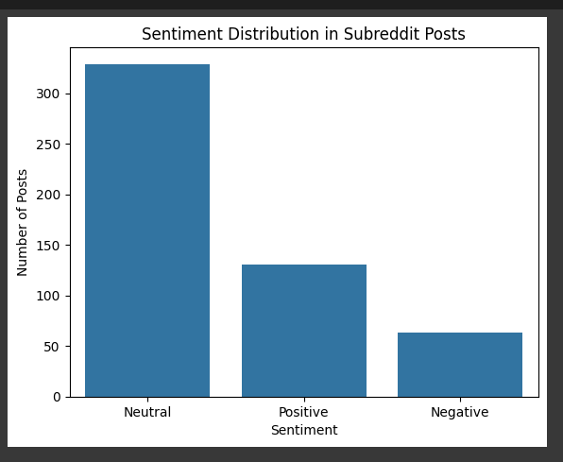

Trends and Popular Topics

Content: Talk about the major themes that have been identified, including conversations about nostalgia, different Coke flavours, and products.

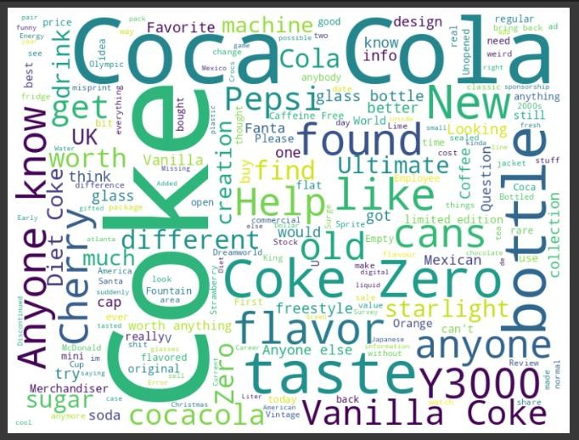

Top Influencers :

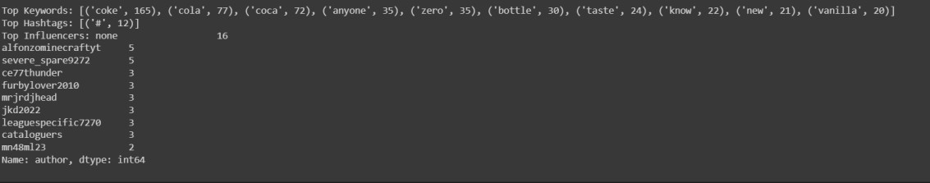

## Conclusion: What We Learned from Listening

We saw directly how people's mutual love of a drink could bring people together on the internet.

The knowledge gathered from this social listening activity highlights how conversations have the

ability to influence how consumers perceive brands. The conversation in the subreddit is about more than just the drink; it's about personal memories, group anticipation of Coca-Cola's upcoming

ventures, and shared experiences.

**Nostalgia as a Cornerstone**: The audience finds great resonance in the brand's rich history. Make the most of this by frequently showcasing nostalgic content. Talk about vintage advertisements, the backstories of famous designs, and significant Coca-Cola events. This kind of content engages the audience's happy memories and fosters an emotional connection.

**Interact with Key Influencers**: Discussions are sparked by prominent subreddit users. Establish sincere partnerships with these influencers to produce content or launch products. This strategy broadens the brand's audience and harmonises its online presence with local authorities.

**Emphasis on Flavour Conversations**: People are very interested in talking about the flavours of Coke. Promote this interaction with posts that are interactive, such as polls or tasters for upcoming flavours. In addition to keeping the community engaged, this also yields firsthand customer insights.

**Maintain a Positive Digital Space**: One of the subreddit's strongest points is how generally upbeat it is. To maintain this mood, keep posting encouraging and interesting content. Encourage a friendly community by responding well to remarks.

**Diversify Content**: While nostalgia is important, you can also engage a wider audience and

strengthen your brand's narrative by incorporating sustainability, a global presence, and community initiatives.

To keep a strong and recognisable online presence, Coca-Cola should combine its historical heritage with contemporary engagement tactics, emphasising influencer cooperation, community connection, and diverse content.